**Mindy Cervoni** President **Anne Spisiak** Vice President and Adult Service I **Jeff Paterson** Treasurer and Government Affairs **Renee Filip** Secretary  **Gwen Squire** Advocate Representative **Denise Jones** Adult Service II **Donna Dedee** Public Relations **Stephen R. Anderson, Ph.D.** Children’s Services **Bryan O’Donovan** At-Large **Anne McCaffrey** At-Large **Kathy Bunce** and **Barb DeLong** Family Co-Chairs **Doug DiGesare** Administrative Services and Workforce Development

September 4, 2024

Acting Commissioner Willow Baer

OPWDD

44 Holland Avenue

Albany, NY 12229

**Advocacy for 41% Increase in Reimbursement Rates and Expanded Services for**

**Respite Care**

Dear Acting Commissioner Baer:

The Developmental Disabilities Alliance of WNY (DDAWNY) is a collaborative group of

member voluntary agencies providing support and services to people with

developmental disabilities. While honoring individual agency missions, the Alliance aims

to assist agencies in developing relationships, promoting unified strategies, and sharing

risks for the benefit of people with disabilities.

On behalf of DDAWNY, we wish to advocate for a 41% regional increase in the

reimbursement rates for Respite and the expansion of the allowable services

reimbursable through the current Administrative Directive Memorandum (ADM).

Current reimbursement rates force provider agencies to operate at a deficit. Data from

our Fall 2023 survey, which included responses from 50 provider agencies across NYS, indicates that over 500 families are currently waiting for relief through Respite services.

This critical matter requires immediate attention. Without investment in these vital

services, there will be an increased burden on our service delivery system, as families

will have to rely on more costly services. For instance, those unable to support their

loved ones at home might seek alternative support within an Individualized Residential

Alternative (IRA), which costs significantly more to the system.

It is unrealistic to expect provider organizations to sustain, let alone increase capacity,

in services that can only be operated at a deficit in our region.

Furthermore, to adequately meet the Respite needs of families in our region, we

recognize the need to enhance service options to include allowable activities provided

to and/or on behalf of a person. Examples include but are not limited to:

* Planning for the delivery of all allowable Respite Services
* Managing the Delivery of Respite Services
* Staff travel time to provide Respite Services
* Rounding units of service for billing
* Retainer Days
* Staff wait times to provide Respite Services

Without investing in Respite, the number of families forced to rely on more costly

services will continue to expand.

Thank you for your time and consideration. We look forward to your positive response

and to working together to ensure rates and regulations allow for a sustainable future.

Respectfully,

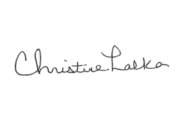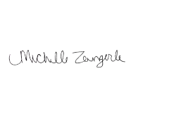

Christine Lalka and Michelle Zangerle

Co-Chairs of Community Habilitation and Respite DDAWNY Committee